Assignment-17.4:

Write some test cases to test a sample Hadoop word count program using MRUnit.

Driver Class:

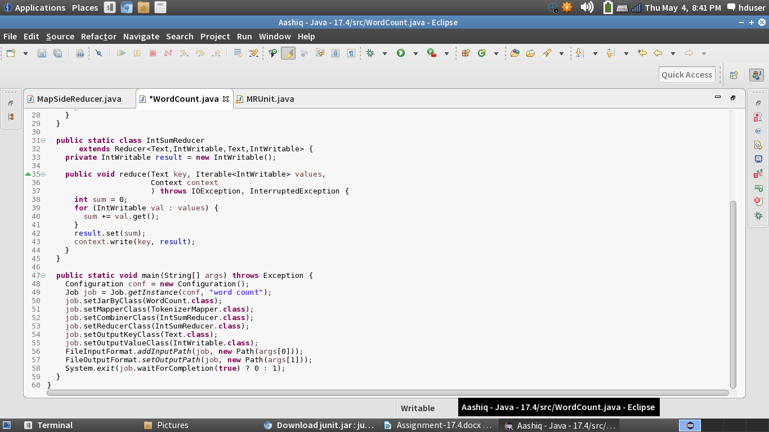

Mapper and Reducer Class:

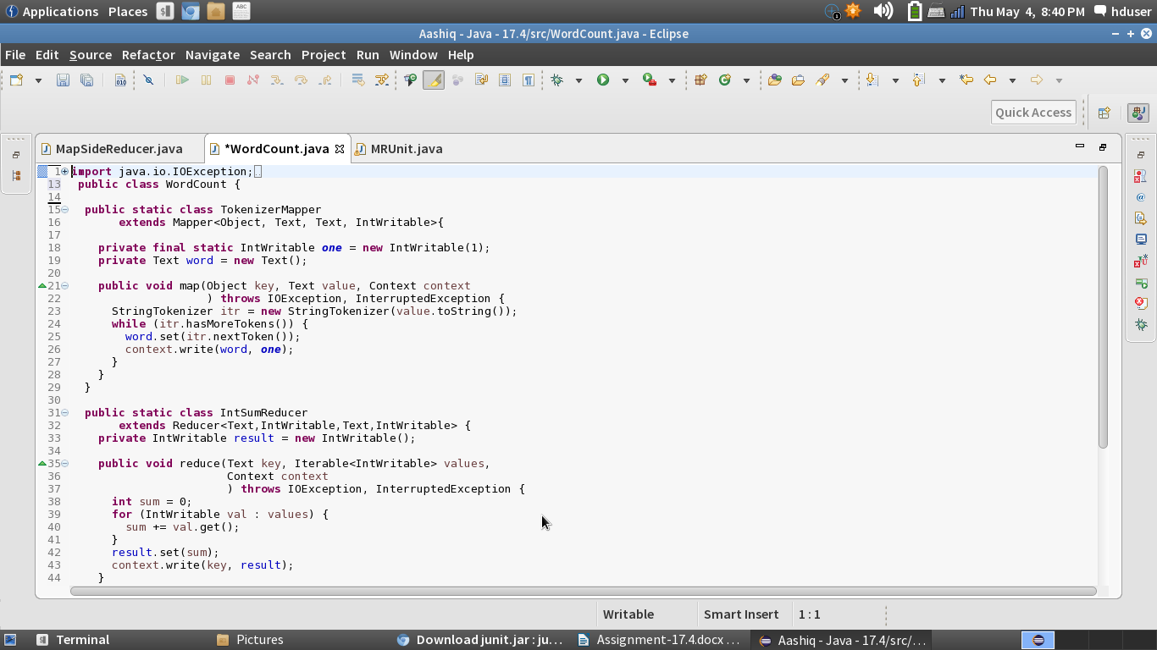

MRUnit:

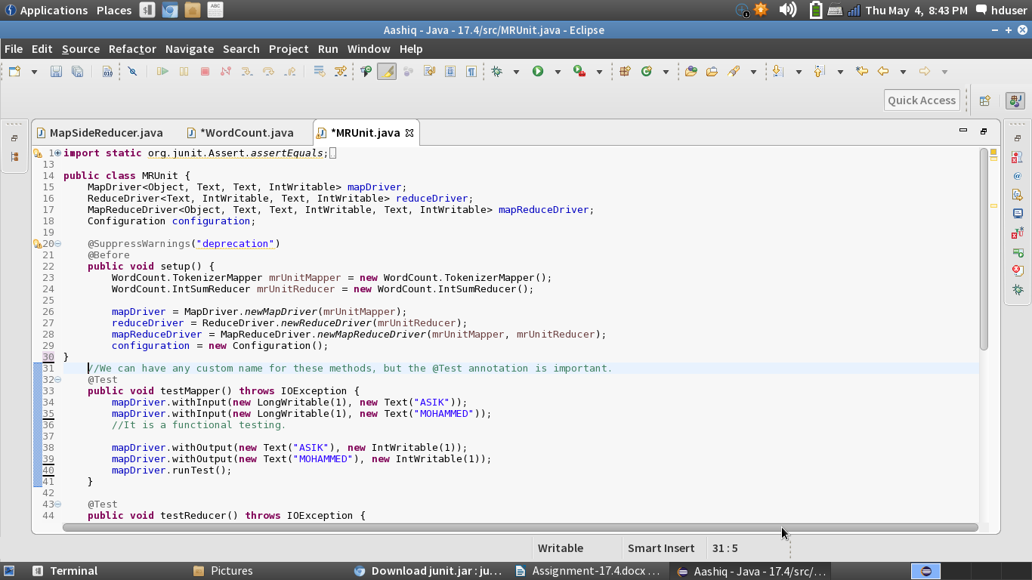

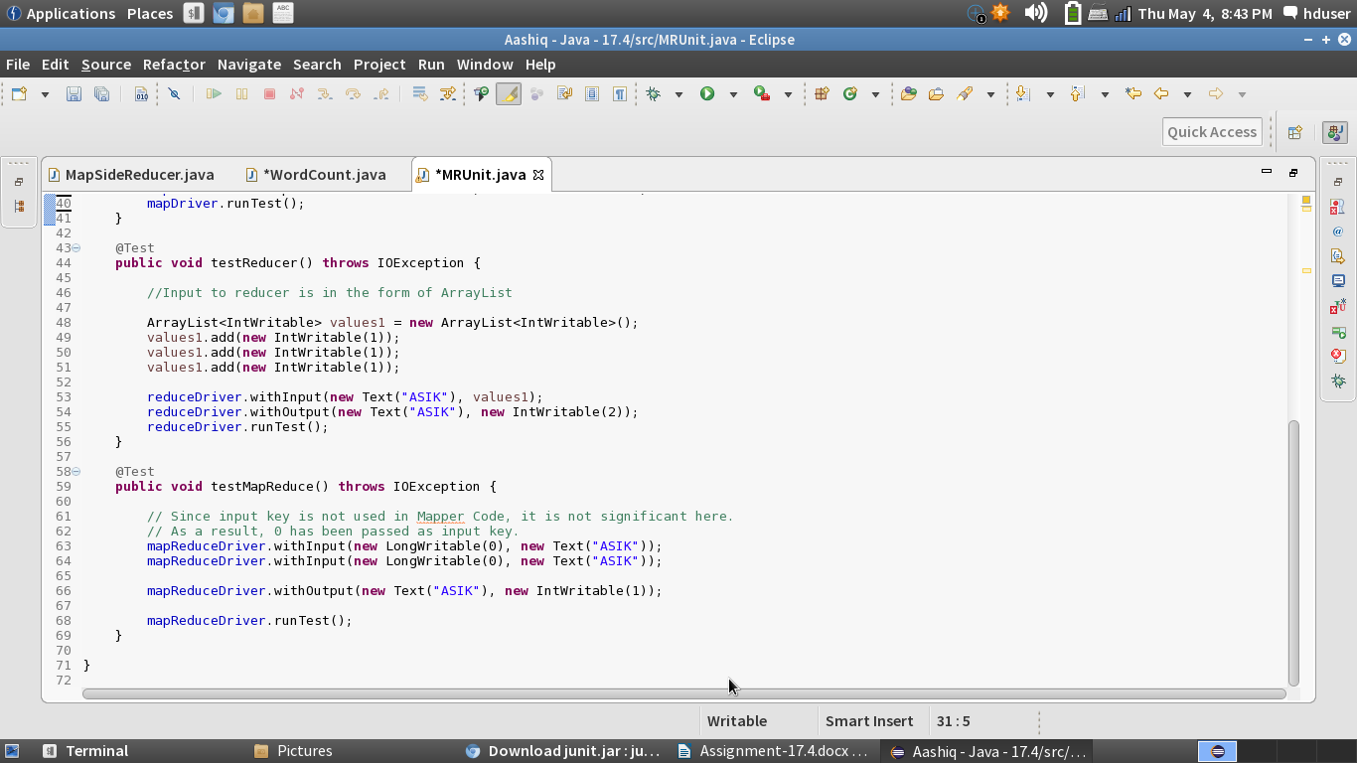

Correct Test Case:

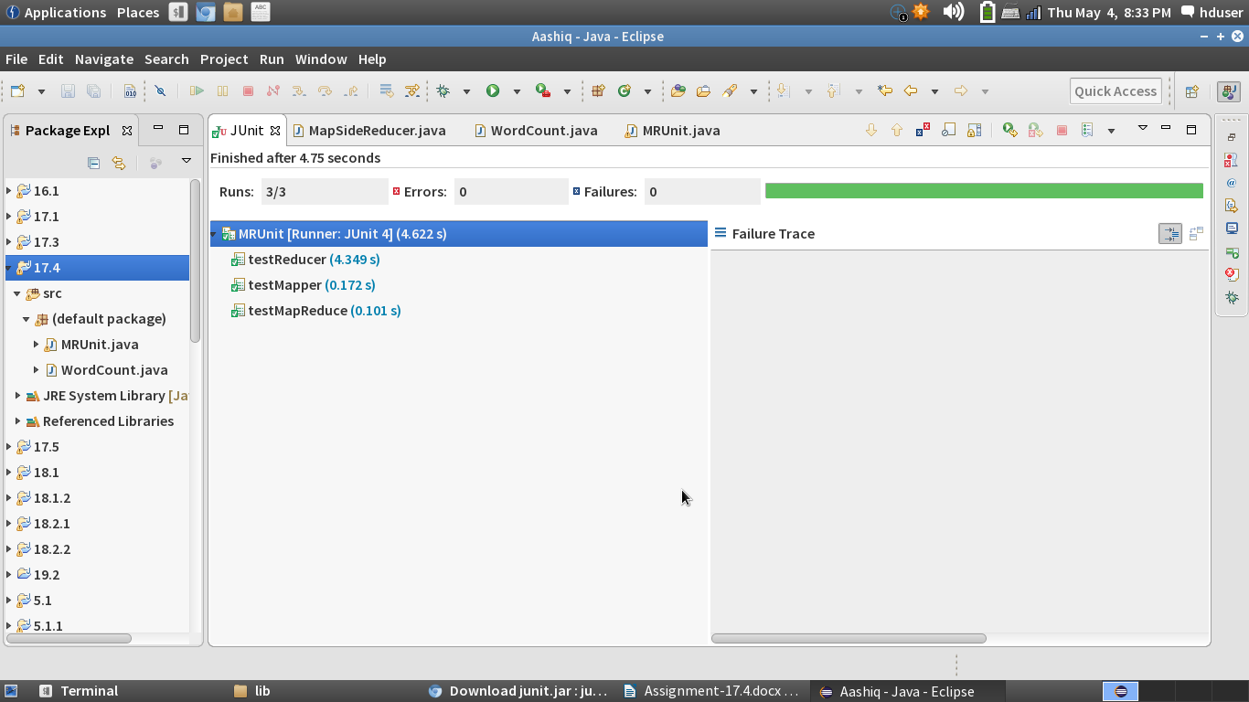

Here we can see that all the values are entered correctly and hence we are getting all the values correct.

Wrong Test Case:

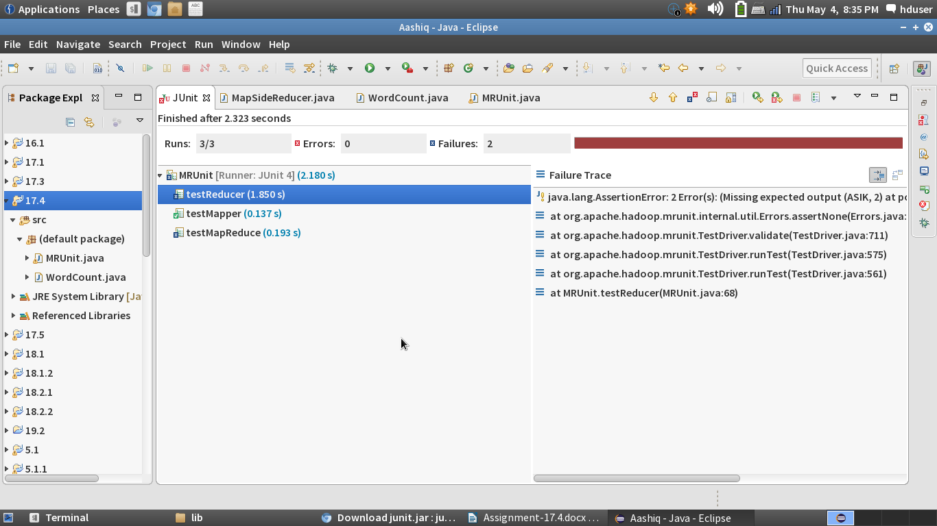

I am entering a wrong value and the test case fails.